Technical Report

MVB Communication Module for Railway Applications

1. Introduction
The modern railway system increasingly relies on robust communication networks to ensure safety, automation, and efficiency. Among the commonly used standards is the Multifunction Vehicle Bus (MVB), governed by the IEC 61375 standard. This document presents a custom-designed MVB communication module developed for onboard railway applications, highlighting its technical features, block architecture, and design rationale.

2. Objective
This module is designed to:
- Enable reliable real-time communication between railway subsystems.
- Provide electrical and protocol interfacing with MVB networks.
- Achieve compact, rugged form factor for rail coach environments.

3. Block Diagram and the Image of Module
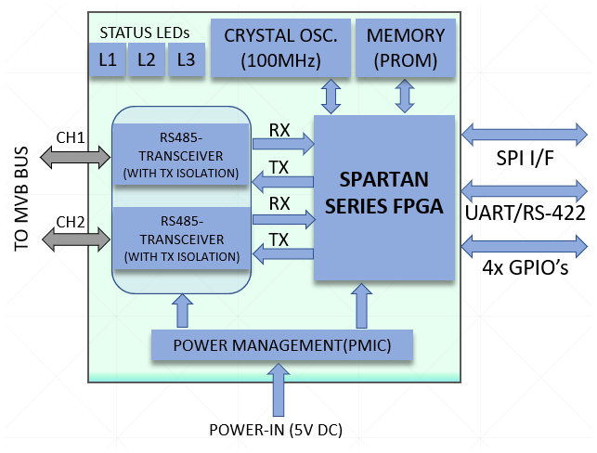
Figure: Custom Designed MVB Communication Module Block Diagram
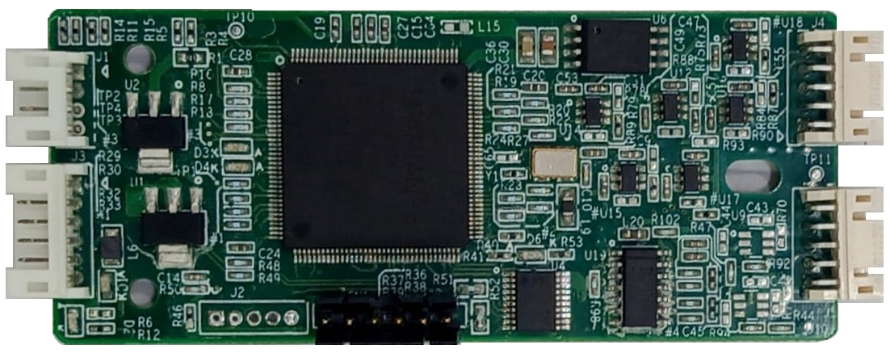
Figure: Custom Designed MVB Communication Module Actual Image

4. System Overview
The MVB module comprises several key subsystems:
- FPGA Core: For protocol parsing, data handling, and diagnostics.
- MVB Physical Layer Interface: Transceivers and filters for MVB signaling.
- Connector Interfaces: For train bus, power supply, and host communication.
- Oscillator & Clock Circuit: Timing synchronization with MVB network.
- Power Conditioning: Voltage regulation and EMI protection.

5. Technical Specifications (Proposed)
Feature | Specification/Details
MVB Standard | IEC 61375-3-1 Compliant
Processor Core | Xillinx Spartan Series FPGA
Data Interfaces | UART, SPI, I²C, RS422 (Configurable)
Operating Voltage | 5V / 3.3V
Protection Features | ESD, Overcurrent, Short Circuit, EMI/EMC
Connectors | 1x 4-Pin Single Row 2mm Pitch Conn. for Power Input  1x 6-Pin Single Row 2mm Pitch Conn. for MVB Data IN/OUT  2x 10-Pin Dual Row 2mm Pitch Conn. for Host Interface (I2C, UART, RS422, SPI etc.)
PCB Dimensions | Approx. 10cm x 3cm
Operating Temperature | -40°C to +85°C (industrial-grade components)

6. Design Considerations for Railway Use
- Electromagnetic Compatibility (EMC): EMI filters and proper shielding ensure signal integrity.
- Mechanical Ruggedness: Vibration-proof connectors and solder joints suited for coach mounting.
- Safety and Redundancy: Electrical isolation and watchdog timers improve fault tolerance.
- Diagnostics Support: On-board test points and debug port allow real-time monitoring.

7. Applications
- Onboard communication between train control units, DDUs and passenger subsystems.
- Data acquisition systems in locomotives or coaches.
- Retrofitting legacy railway systems with modern digital buses.

8. Novelty & Patentability
The module design introduces:
- A compact and integrative form factor.
- Custom arrangement of I/O for ease of integration.
- FPGA/software-configurable logic for flexible deployment.
- Robust electrical protections specific to rolling stock environments.

9. Conclusion
This MVB communication module provides a tailored solution for the railway industry, conforming to relevant standards while incorporating design innovations that enhance its deployability, reliability, and versatility. It is a promising candidate for patent protection under utility and design categories.

